Contents
1 Introduction 1
2 Australian coding standards for Endoscopy 2
2.1 Definition of same-day endoscopy 2
2.2 ACS 0051 same day endoscopy – diagnostic 3
2.3 Implications of a Causal Link 3
2.4 Coding incidental findings 4
2.5 ACS 0052 same day endoscopy – surveillance 5
2.5.1 Surveillance for Family history (FH) 6
2.5.2 Surveillance for Personal history (PH) malignant neoplasm 6
2.6 Lead Terms for surveillance 7
2.7 Surveillance - Check endoscopy 7
3 Procedure not completed or interrupted 8
4 Gastroenteritis (GE) 8
4.1 Scenarios for Gastroenteritis 8
4.2 Exercise 1 Gastroenteritis 9
5 Gastrointestinal haemorrhage 9
5.1 Exercise 2 – Gastrointestinal haemorrhages 9
5.2 Endoscopic procedures 10
5.3 Cancelled and abandoned Procedures 10
5.3.1 Exercise 3 Cancelled procedures 10
6 Scenarios and Practice Exercises 11
6.1.1 Exercise 4 - Family History 11
6.1.2 Exercise 5 - Personal History 12
6.1.3 Exercise 6 - Incidental Findings and Causal Relationships 12
7 Minimal Documentation 13
Exercise 7 - Minimal documentation 14
8 Scenarios and Exercises 14
8.1 Day Endoscopy for Polyps 14
8.1.1 Exercise 8 Day endoscopy for polyps 14
9 Colonoscopy and Gastroscopy 14
10 General Endoscopy 15
10.1.1 Exercise 9 General endoscopy 17

Introduction


Endoscopy is not the easiest topic, but it has some fairly simple rules that you need to follow.

There are several questions that the coder needs to ask before coding endoscopy, and they relate to why the patient is having an endoscopy.

Is it for a:
Diagnostic endoscopy
- They have symptoms and need to determine if there is an underlying diagnosis
- They have an existing chronic condition that requires regular endoscopy
Surveillance endoscopy
- They have a past history of a condition, which requires regular follow-up
- Someone in their family has a condition or a history of a condition, that could be hereditary, and therefore requires regular follow-up
- There is another reason why they are having an endoscopy

This Learner’s Guide will teach you the rules for coding Diagnostic and Surveillance endoscopy, and other rules relevant to coding endoscopy and applying these rules to the coding process.

Australian coding standards for Endoscopy
The Australian Coding Standards (∇ACS ) are written and maintained by IHACPA (https://www.ihacpa.gov.au/) to ensure that everyone codes in the same way using ICD-10-AM. This will result in consistency of the coded data reported to authorities. The standards provide you with rules that you must follow when coding.

There are several ∇ACS that re relevant to coding Endoscopy.
∇ACS 0051 Same-day endoscopy – diagnostic.
∇ACS 0052 Same-day endoscopy – surveillance.
∇ACS 0024 Panendoscopy.
∇ACS 1103 Gastrointestinal (GI) haemorrhage.
∇ACS 0237 Recurrence of malignancy

Definition of same-day endoscopy
This definition applies to ∇ACS 0051 Same-day endoscopy – diagnostic and ∇ACS 0052 Same-day endoscopy – surveillance.

Definition of Same day Patients
- Those admitted and discharged on the same day.
- those admitted with the intent of being Day Stay patients. This means that if they are required to stay longer, they still meet the definition of a Same-Day patient.
- Those admitted the day before because they need “support/supervision with the endoscopy preparation”. For example, these patients may not be able to use the bowel preparation on their own, and have no one at home to help them with this.

∇ACS 0051 and ACS 0052 apply to “endoscopic investigation of any body system” which includes gastroscopy, colonoscopy, bronchoscopy, laryngoscopy, arthroscopy, and ERCP.

ACS 0051 same day endoscopy – diagnostic
Terms relating to ∇ACS 0051.
An indication is the reason for the admission/procedure. This may be synonymous with symptoms.
A Finding is the condition found during the procedure.
A causal link is a statement by the clinician of a relationship between the indication and the finding. A causal link may be documented as “due to” or “indicative of”, or “caused by” or similar terms.

A diagnostic endoscopy is where:
- The endoscopy is being undertaken to determine a diagnosis for a patient who has symptoms/indications that require investigation to confirm/deny a condition.
- The result of a diagnostic endoscopy may be that:
  - the indication/symptoms are the only conclusion, or
  - there is an underlying condition (the finding) causing the symptoms.
- The endoscopy is for review of chronic incurable conditions such as coeliac disease, Crohn's disease and ulcerative colitis that cannot be eradicated but require ongoing treatment and management.

The main points in ∇ACS 0051 are:
- If a condition (the finding) is found and is stated to be the cause of the reason for the admission (the indication), then the finding and not the reason for the admission is assigned a code.
- All other findings are also coded (ACS 0002 does not apply).
- ∇ACS 0002 Additional Diagnoses DOES NOT APPLY to cases meeting the requirements of ∇ACS 0051.

Implications of a Causal Link
A “causal link” is a statement by the clinician that the symptom/indication has been caused by the finding.
For example:
- the patient is admitted for anaemia.
A gastric ulcer is found at surgery (gastroscopy)
The coder may not assume that the anaemia was caused by the ulcer.
If the clinician documents in the record that the anaemia was caused by the ulcer, then the ulcer becomes the Principal Diagnosis (PDx) and the anaemia is not coded.

If the clinician makes no statement of a “causal relationship” between the anaemia (the indication) and the ulcer (the finding), then the anaemia is the reason for admission and is hence the PDx, followed by the finding of the ulcer as an associated diagnosis.
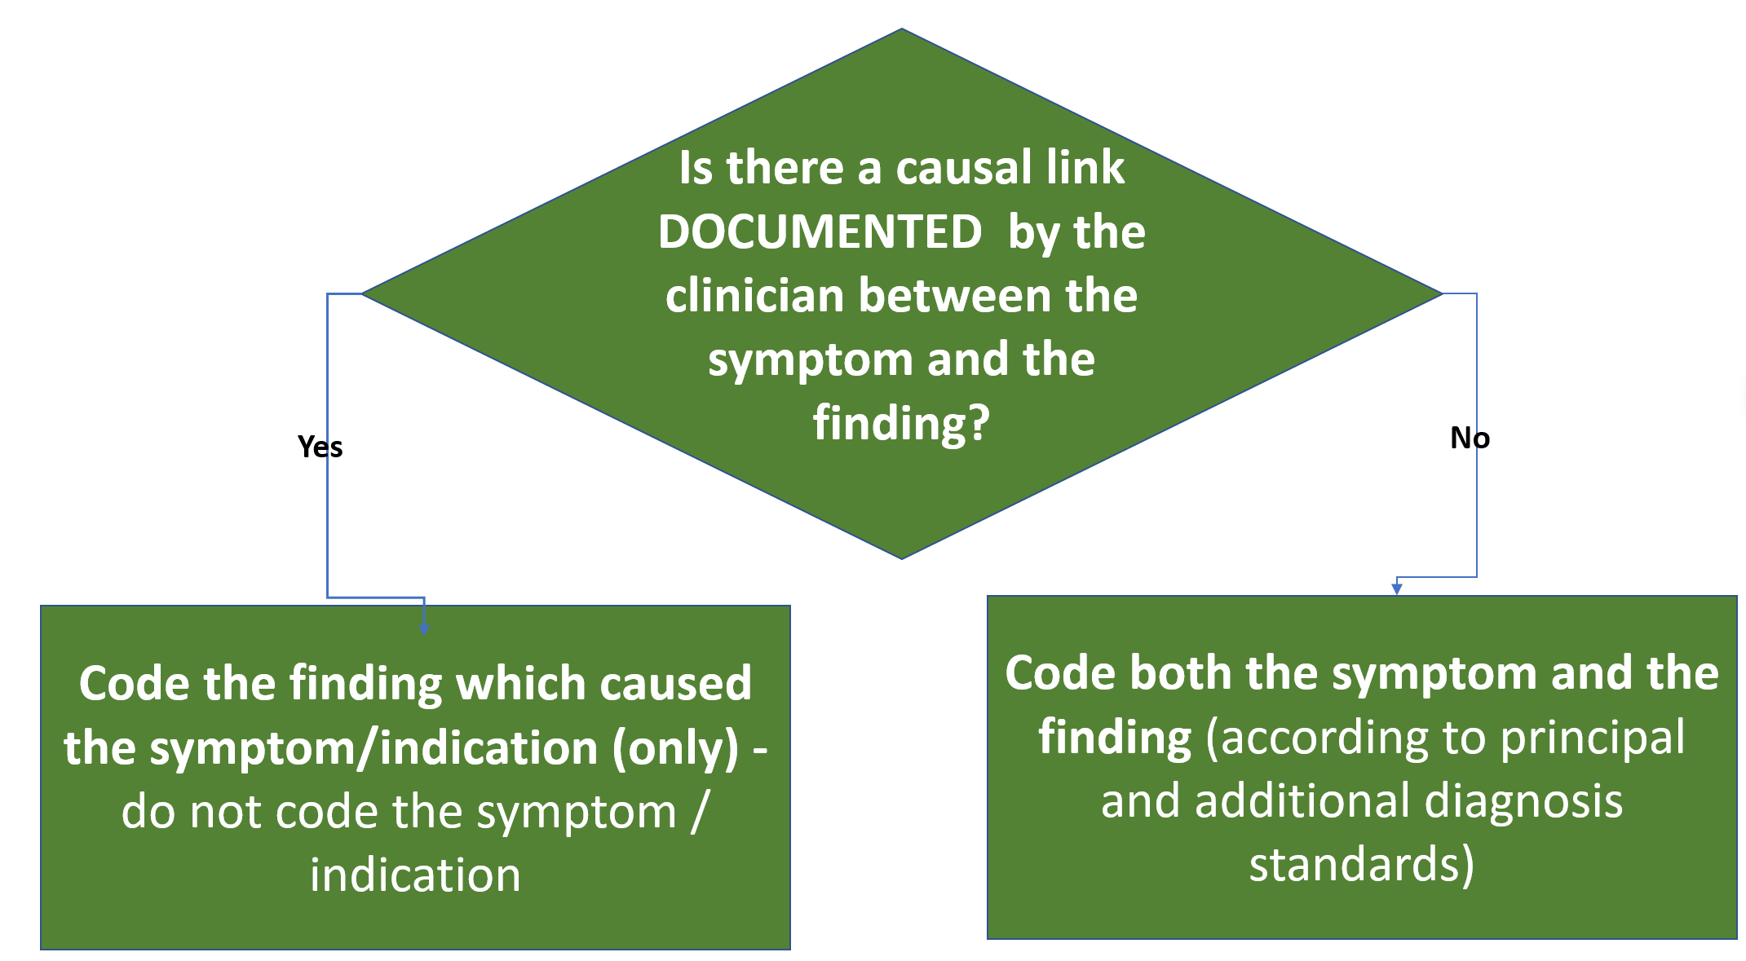
See the examples in ∇ACS 0051 Same-day endoscopy – diagnostic

Coding incidental findings
An Incidental Finding is a condition noted by the clinician during a test or a procedure. This condition is unrelated to the reason for the admission or the procedure, and is called an incidental finding.

Note that under the heading Classification, point 1.1, dot point 2, the standard states:

“assign codes for all other findings as additional diagnoses (note these findings do not need to meet the criteria in ACS 0002 Additional diagnoses).”

The words “all other findings” can be interpreted as “incidental findings”.

This standard is telling us to assign codes for incidental findings for DIAGNOSTIC same day cases, and that this is an EXCEPTION to ∇ACS 0002 Additional diagnoses.

Example of incidental finding:
Patient admitted for screening for past history of polyps. No polyps found. During the colonoscopy the surgeon noted that the patient had diverticulosis.
The diverticulosis is an incidental finding, it was not the reason for the procedure, and was not treated.
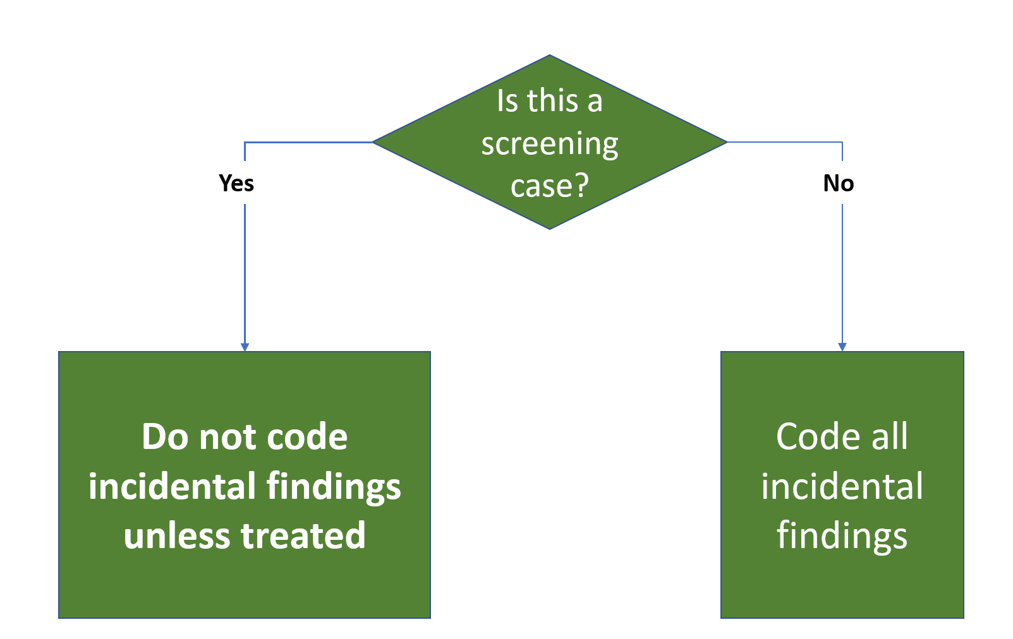

ACS 0052 same day endoscopy – surveillance

Definition of Screening/surveillance: “The term "screening" refers to the regular use of certain examinations or assessments in people who do not have any symptoms”. Be aware that just because the word screening is used in the record does not mean that the person who wrote the record is using the definition we have here and do not let the documentation mislead you to coding screening when the case does not meet the requirements for coding of screening.

A screening case can be where a patient is admitted for:
- Check-up because there is a family history of a condition, which may result in the patient having the condition (malignant or non-malignant)
- Check-up because the patient has a history of a condition (malignant or non-malignant)

See the dot points at the start of ∇ACS 0052 which define “endoscopic surveillance”.
This standard defines surveillance as:
- Follow-up of conditions previously treated and thought to be cured (personal history)
- Review of chronic incurable conditions (personal history)
- Screening of conditions that have the potential for malignant transformation.
- Screening for risk factors
- Screening for family history of cancer or gene mutations (eg. FAP or HNPCC)
- Other screening

The important point for this standard is:
- Z09 - and Z08 - cannot be used as an Associated Diagnosis except in cases where, for example, a gastroscopy for abdominal pain was coded first, followed by a colonoscopy for screening with no recurrence found.

Surveillance for Family history (FH)
If a patient has a family history of cancer, or polyps, then there is a likelihood that they will also develop this condition (and polyps have the nasty potential of malignant transformation). These patients have an endoscopy regularly to screen them for the condition.
See ∇ACS 0052 Same-day endoscopy - surveillance – Code Z11 or Z12 or Z13 should be the Principal Diagnosis for admissions where the patient is admitted because of a family history of a condition. If the condition being screened is found, then assign the condition, and NOT the Z11 or Z12 or Z13 code.

IF family history of a condition
AND no condition is found.
THEN code PDx Z11 or Z12 or Z13 (Lead Term Screening, - neoplasm)
THEN assign a code from Z80.- or Z85.- (Lead Term History, - family)

IF family history of a condition
AND the condition is found.
THEN code PDx the condition
AND a code from Z80.- or Z85.-(Lead Term History, - family)
AND not Z11/2/3 Screening

Surveillance for Personal history (PH) malignant neoplasm
Patients who have a personal history of cancer are regularly reviewed for recurrence of the malignancy.
See ∇ACS 0052 Same-day endoscopy - surveillance
IF personal history of a malignant neoplasm
AND no neoplasm is found
THEN code PDx Z08.x (Lead Term Examination, - follow-up, - - malignant…)
THEN Z85.x .-(Lead Term History (of)(personal), - malignant neoplasm)

IF personal history of a malignant neoplasm
AND the neoplasm is found
THEN code PDx the neoplasm
AND not Z85.x
AND not Z08.- Follow-up after treatment for malignancy

Personal history non malignant condition
See ∇ACS 0052 Same-day endoscopy - surveillance IF personal history of a non-malignant neoplasm
AND no neoplasm is found
THEN code PDx Z09.x (Lead Term Examination, - follow-up, - -treatment,…
THEN Z86.x OR Z87.-

IF personal history of a non-malignant neoplasm
AND the non-malignant neoplasm is found
THEN code PDx the non-malignant neoplasm
AND not Z86/7.x
AND not Z09.- Follow-up after treatment

Z09.- Pay attention to the 4th digits for Z09.-.
For example, if the patient has a history of peptic ulcer (can be diagnosed by surgery or otherwise), you may not assume that the history involves treatment, - assign code Z09.8 in this case. A history of a polyp does NOT assume surgery.
Where a patient is admitted for follow up for treatment of a previous condition, and the previous treatment is not specified, then use code Z08/9.8 Follow-up examination after other treatment for other conditions.

Follow the pathway in the Disease Index:
Examination
- follow-up
- - Treatment for
- - - specified condition Z09.8

This diagram may help your understanding of ∇ACS 0052 Same-day endoscopy - surveillance

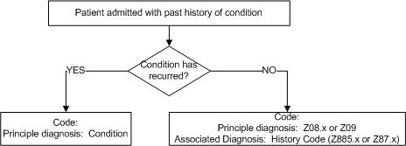

Lead Terms for surveillance
In conclusion:
- Lead term for the PDx for admission for a Family History is Screening
- Lead term for the PDx for a personal history is Examination

Surveillance - Check endoscopy
This phrase can have several meanings, and you need to read the medical record to determine why the patient is being admitted.
The phrase “Check endoscopy” can be used for cases where the only documentation written in the medical record is “for endoscopy” or similar unhelpful statements from the doctor. “Check endoscopy” can be used to indicate that the patient is admitted for follow-up after previous surgery OR is being checked because of a family history.
In the absence of advice from a clinician as to why the endoscopy was performed, for the Principal Diagnosis assign code Z01.8 other specified examination where no findings are documented.
See ∇ACS 0051 point 2, No symptom/condition documented as the indication for endoscopy:

Procedure not completed or interrupted
∇ACS 0019 states:
IF an intervention was abandoned, interrupted, or not completed, assign the following Dx codes:
- A code for the condition requiring intervention (PDx)
- Z53.3 Procedures abandoned after initiation as an additional diagnosis.
- A code for the condition or complication responsible for the abandonment of the intervention, as an additional diagnosis, if applicable

The examples given for this standard are a little too complicated for beginners of this course, so here is my example. (Make sure that you look up and understand the difference between a colonoscopy and an endoscopy first).

Example for ∇ACS 0019
Patient admitted for colonoscopy. The surgeon was only able to advance the endoscope to the sigmoid colon.
In this case you code the ACHI code for sigmoidoscopy as a colonoscopy could not be done.
THEN assign code Z53.3

Gastroenteritis (GE)
See ∇ACS 1120 Dehydration with Gastroenteritis.

The default code for Gastroenteritis is A09.9 – Gastroenteritis and colitis of unspecified origin. This is the code to use when you do not know whether the gastroenteritis is infective or not.

If the gastroenteritis is documented as infectious, either code A09.0 Other gastroenteritis and colitis of infectious origin, or a code from the range A04 to A08 if the specific cause of the infection can be assigned a code.

If the gastroenteritis is clearly documented as NOT infectious, use the Lead Term:
Gastroenteritis,
- non-infectious,
and code K52.9.

Scenarios for Gastroenteritis
Scenario
Patient admitted with D & V over 5 days. Stool sample found clostridium difficile, which was treated with antibiotics
Principal Diagnosis  A04.7 | Enteritis due to Clostridium difficile  The Lead Term for this code is Enterocolitis, - due to Clostridium difficile. It is not listed under “enteritis” or under “gastroenteritis”.

Scenario
Baby diagnosed with viral GE. Admitted for rehydration
A08.4 | Viral gastroenteritis – See ACS 1120 re dehydration with gastroenteritis

Scenario
Toddler admitted with dehydration. Treated with antibiotics for presumed bacterial GE.
Principal Diagnosis A04.9 | Bacterial enteritis the Lead Term is Enteritis
Associated Diagnosis E86 | Dehydration – See ∇ACS 1120 “Dehydration with gastroenteritis”

Exercise 1 Gastroenteritis
Information in the record | Code/s
- Diagnosed with gastroenteritis due to allergy to various foods
- Admitted with severe gastroenteritis due to ingestion of a mixture of medications
- Admitted with severe gastroenteritis

Gastrointestinal haemorrhage
∇ACS 1103 Gastrointestinal (GI) haemorrhage.

The important point here is that where conditions of the upper GIT are found, and there is upper GIT haemorrhage (e.g. haematemesis) then the condition found should be coded as with haemorrhage.

NOTE that this DOES NOT APPLY to haemorrhage from the lower GIT.
WHY? Because haemorrhage from the lower GIT could be from anywhere along the GIT (upper or lower).

Where the code does not include the text “with haemorrhage” then K92.x should be assigned to indicate haemorrhage.

Exercise 2 – Gastrointestinal haemorrhages
Complete these practice coding exercises then look up the correct answers and comments in the answers document on the course site.
Information in the record | Code/s
Day Patient admitted for history of recent haematemesis. Gastroscopy report documented chronic gastric ulcers, with no bleeding noted.

Day Patient admitted for colonoscopy for PR bleeding and banding of grade II haemorrhoids. Colonoscopy report documents no abnormalities found.

Day Patient admitted for colonoscopy for PR bleeding. At colonoscopy, a tubulovillous adenoma of the sigmoid colon was excised.

Day Patient admitted for gastroscopy for melaena, and abdominal pain. Gastroscopy report documented chronic gastritis.

Endoscopic procedures
Endoscopic procedures include
- Colonoscopy
- Gastroscopy
- Panendoscopy – note that some procedures that you may expect to find under “gastroscopy” are listed under “panendoscopy” when the scope continues past the duodenum. Look up “panendoscopy” in the ACHI Index and look at the procedures listed under this term.
- Endoscopy with tattoo
- Pill Camera
- Endoscopic Ultrasound
- Argon Plasma Coagulation
- Double Balloon Endoscopy

Cancelled and abandoned Procedures
It is often the task of the Clinical Coder to bring cancellations to the notice of the Admission Clerk. However, there will be situations where the patient is admitted and prepared for surgery, after which the surgery is then cancelled. In this case the patient has been assessed by a clinician after having been admitted, hence the episode must be coded as a cancelled procedure as it is NOT as a cancelled admission.

Where the patient is not admitted and does not attend (DNA) then the admission should be cancelled, and not coded.

See ∇ACS 0011 Admission for Surgery not performed.
Where surgery is cancelled after the admission of the patient, code:
- the reason for admission
- Z53.x Surgery cancelled.
- Code the reason for cancellation if a patient condition.

Scenarios for cancelled procedures
Scenario
Day Patient admitted for polypectomy – polyps of the ascending colon noted on ultrasound. Assessment by the anaesthetist found rapid atrial fibrillation, and the surgery was cancelled
Code | Term
Principal Diagnosis K63.50 | Polyps of colon – unspecified
Associated Diagnosis Z53.0  Associated Diagnosis I48.9 | Cancelled procedure for contra-indication.  Atrial fibrillation was the contra-indication

Exercise 3 Cancelled procedures
Information in the record | Code/s
Day Patient admitted for colonoscopy for GIT bleeding. Patient noted to have had cup of tea in last half hour. Surgery cancelled
Day Patient admitted for abdominal pain for colonoscopy and gastroscopy. Procedure cancelled as surgeon still working on long difficult case. Patient to return next week.

Scenarios and Practice Exercises

Here are some Coding Scenarios for you to practice coding. Read each scenario which includes information from the patient’s record. Look up the codes in ICD-10-AM and ACHI and follow the steps of the coding process.

Practice coding each scenario without looking at the answers.

The Coding Scenarios provide you with examples of Endoscopy coding and should give you sufficient knowledge for you to be able to code other diagnoses and procedures not specifically covered in this course. The important thing is that whenever you have to code a diagnosis, or a procedure, make sure that you know what it means, and how it is performed.

A good plan of attack for understanding the following scenarios is to start by noting down the Lead Term for the Diagnosis/es, and the Main Term for the procedure/s

The Scenarios Are:
- Family history
- Personal history
- Incidental findings
- Coding with minimal documentation
- Polyps
- Cancelled procedures.
- General Endoscopy coding
- Gastroenteritis
Each of these headings has examples of different coding situations and the codes appropriate for the case.

Exercise 4 - Family History
Complete these practice coding exercises then look up the correct answers and comments in the answers document on the course page.
Information in the record | Code/s
Day Patient admitted for family history of cancer of the colon. Colonoscopy found no abnormality
Day Patient admitted for family history of cancer of the colon. Colonoscopy found Cancer of the colon
Day Patient admitted for family history of cancer of the colon. Colonoscopy found no cancer but did find diverticulosis of the colon.
Day Patient admitted for family history of cancer of the colon. Colonoscopy found cancer of the colon and polyps of the colon
Day Patient admitted for family history of cancer of the colon. Colonoscopy found Cancer of the colon and hyperplastic polyps of the colon. The polyps were removed by polypectomy.
Day Patient admitted for family history of cancer of the colon. Colonoscopy found Cancer of the colon and polyps of the colon. The polyps were removed by polypectomy, and the cancer was biopsied.

Exercise 5 - Personal History
Information in the record | Code/s
Day Patient admitted for personal history of polyps of the colon. Colonoscopy found no abnormality.
Screening for personal history
Day Patient admitted for personal history of polyps of the colon. Colonoscopy found recurrence of polyps, with polypectomy of polyps.
Screening for personal history
Day Patient admitted for personal history of polyps of the colon. Colonoscopy found no recurrence of polyps.
Screening for personal history
Day Patient admitted for personal history of cancer of the colon. colon (hemicolectomy 2 years ago). Colonoscopy found no cancer, but did find diverticulosis of the colon
Screening for personal history
Day Patient admitted for personal history of cancer of the colon. Colonoscopy found Cancer of the colon and polyps of the colon. The polyps were removed by polypectomy
Day Patient admitted for personal history of cancer of the colon. Colonoscopy found cancer of the colon and polyps of the colon. The polyps were removed by polypectomy, and the cancer was biopsied

Exercise 6 - Incidental Findings and Causal Relationships
Information in the record | Code/s
Day Patient admitted for haematemesis and altered bowel habit. Gastroscopy undertaken, and chronic gastric ulcer found.
Note: This is not a screening case, the patient has been admitted with symptoms. Search the internet to find out what a gastroscopy is before you code it.
Day Patient admitted for bleeding per rectum. Colonoscopy undertaken, and haemorrhoids banded. Diverticulosis of colon noted
Day Patient admitted for investigation of abdominal pain. Gastroscopy found chronic gastritis which was biopsied and confirmed by pathology. Operation report states “gastritis consistent with abdominal pain”.
Day Patient admitted for investigation of heart burn. Gastroscopy with CLO assessment confirmed chronic H. pylori gastritis and also gastro-oesophageal reflux disease confirmed as the cause of heart burn,
Note: H. pylori is an abbreviation for helicobacter pylori.
CLO assessment is “campylobacter like organism assessment”, which is undertaken to assessment for H. pylori.

Minimal Documentation
If Clinical Coders worked in the best of all possible worlds (with apologies to Voltaire), then clinicians, (particularly surgeons) would document everything that they do, and WHY, in beautiful, readable script.


In the real world the doctors are usually considering only how they care for the patient and the needs of documentation and coders are often secondary. It is rare that we get beautiful records.
Frequently the Clinical Coder will be faced with the text “for endoscopy” next to the heading “reason for admission”, a description of the procedure performed, and no documentation of the finding or diagnosis/or a completely normal finding/diagnosis.

To be clear – the condition documented is a procedure (not a diagnosis or symptom). What to do?

There are two scenarios:
Use Z13.83 if a screening case for a particular disease, and no disease is detected.
Use Z01.8 if there is no indication as to why the procedure is being performed, and no finding on the operation report.

Scenario for Z01.8
Day patient admitted with “for colonoscopy” documented as the reason for admission. Colonoscopy performed and documented as NAD
Z01.8 | Other specified special examinations. This is the code to use in the absence of any further documentation.
32090-00 | Colonoscopy

Scenario for Z13.83
Day patient admitted for a gastroscopy for a suspicion of gastric ulcers. Gastroscopy performed with result on operation report documented as “NAD”
Z13.83 | Special screening examination for digestive tract disorder.
30473-00 | Gastroscopy

Exercise 7 - Minimal documentation
Information in the record | Code/s
Day patient with “for gastroscopy” documented as the reason for admission. Gastroscopy performed and gastric polyp noted. Gastric polyp removed

Scenarios and Exercises

Day Endoscopy for Polyps
Scenario
Day Patient admitted for colonoscopy. Polyp removed from sigmoid colon and reported by pathology to be a tubulovillous adenoma.
D12.5  M8163/0 | Benign neoplasm of sigmoid colon  Morphology code for tubulovillous adenoma (TVA)
32093-00 | Colonoscopy polypectomy

Exercise 8 Day endoscopy for polyps
Information in the record | Code/s
Day Patient admitted for colonoscopy. Polyp removed from descending colon and reported by pathology to be serrated adenoma.

Colonoscopy and Gastroscopy
Endoscopy and colonoscopy are sometimes performed during the same admission – for example, a patient may have symptoms that require a gastroscopy, and it is nearly time for their regular colonoscopy, so the surgeon decides to do both procedures at the same admission.
This can be a problem for Clinical Coders –

What is the Principal Diagnosis? How do I code two Reasons for Admission in the one admission with no documentation of Principal Diagnosis/primary reason for admission?

Where there is no documentation of a Principal Diagnosis for an admission for both Gastroscopy and Colonoscopy - See ∇ACS 0001, subheading Two or more diagnoses that equally meet the definition for Principal Diagnosis- “… code as the principal diagnosis the first mentioned diagnosis.” One place to look for the first mentioned diagnosis may be on the referral form to the Day Surgery from the Surgeon.

Note: Do not code the Principal Diagnosis on the basis of the first finding documented on the histopathology report.

Note: Do not code the Principal Diagnosis on the basis of the first form filed in the Medical Record by the assembly clerk.

There are no rules about coding colonoscopy and gastroscopy in the same admission, so I’m going to provide you with a guideline:

Guideline
Treat each procedure as a separate admission, and code accordingly.

See the following scenario:

Scenario
Gastroscopy: Indication: anaemia, ulcer exclusion, Fe def.
Procedure and findings: gastroscopy, reflux oesophagitis, HH, gastric ulcer, gastritis
Colonoscopy Indication: FU previous polyp
Procedure and findings: colonoscopy with excision of rectal polyp. Diverticulosis also noted.
Histopathology:
Colon: Rectal polyp: hyperplastic polyp.
Stomach: Barrett’s oesophagus; Histological changes of a chemical/reactive gastritis and regenerative changes in keeping with a healing ulcer. These appearances commonly result from ingestion of non-steroidal anti-inflammatory drugs. No helicobacter identified.
Principal Diagnosis: | D64.9 | Anaemia
Associated Diagnosis | E61.1  K21.0  K44.9  K25.9  K29.60  Y45.3  Y92.22  K62.1  K57.30 | Iron deficiency – it is not stated to be iron deficiency anaemia.  Reflux oesophagitis  Hiatus Hernia  Gastric Ulcer  Chemical/reactive gastritis – neither of these terms is documented in ICD-10-AM Disease index, so assign the code for “other gastritis”. The documentation of “gastritis” on the operation report is further defined in the histopathology report.  Complication of NSAID – do not code diagnoses from the histopathology report that are not supported by documentation by the surgeon/clinician.  Rectal polyp  Diverticulosis – the colonoscopy is a screening colonoscopy, so you must follow the rules in ∇ACS 0052 and NOT code incidental findings on the colonoscopy
Principal Procedure: | 30473-01  32093-00 | gastroscopy with biopsy  Colonoscopy with polypectomy
The gastroscopy is documented first, so the indication for the gastroscopy becomes the PDx.
Code all of the codes relevant to the gastroscopy report, noting that this is not a screening gastroscopy – see ∇ACS 0051 Same-Day Endoscopy - diagnostic.
THEN code the colonoscopy. This is a screening colonoscopy, so ∇ACS 0002 applies.

General Endoscopy
Scenario
Patient admitted for gastroscopy with history of haematemesis. Gastroscopy found angiodysplasia with haemorrhage. Angiodysplasia treated with Argon plasma coagulation (APC)
Code | Term
Principal Diagnosis  K31.82 | Angiodysplasia of stomach with haemorrhage  See ACS 1103 to explain why haematemesis is not coded
Procedure  30478-20 | Panendoscopy with Argon Plasma Coagulation

Scenario
Patient with gastrointestinal (GIT) bleeding admitted for double balloon endoscopy (DBE) to ileum. Gastroscopy showed no abnormality. Scope advanced to ileum and extent of scope tattooed. | Note: A double balloon endoscopy enables the endoscopist to view beyond the stomach and the duodenum to the ileum.  See http://doubleballoonenteroscopy.com/ and click to view the animated procedure.  Search the internet for “double balloon endoscopy”
Code | Term
Principal Diagnosis K92.2 | Gastrointestinal bleeding
Procedure 30473-08 | Panendoscopy to ileum with administration of tattooing agent

Scenario
Patient admitted for pill cam for GIT bleeding | Note: “Capsule endoscopy is a new technology designed to examine the small bowel. The assessment involves swallowing a capsule (About the size of a large vitamin capsule) that takes multiple digital photos of the small bowel. The images are transmitted via small sensors attached to the abdomen with adhesive stickers. The small bowel is about 6 metres long and the capsule takes about 8 hours to travel through it”  http://www.digestivehealth.com.au/pillcam.htm  Search the internet for “pill cam” or “pill camera” to learn more
Code | Term
Principal Diagnosis  K92.2 | Gastrointestinal bleeding
Principal Procedure  11820-00 | Panendoscopy by camera capsule

Exercise 9 General endoscopy
Information in the record | Code/s
Patient with ulcerative colitis admitted for colonoscopy (has an annual colonoscopy for this condition). Quiescent ulcerative colitis noted on colonoscopy. Multiple biopsies taken, NAD on operation report.

Note: Ulcerative colitis is a chronic condition, patients will have remissions and recurrences of the disorder, but no final cure.
Patient admitted for annual review of on-going Crohn’s Disease. Colonoscopy reported no flare-up of Crohns, multiple biopsies taken. Tubular adenoma in sigmoid colon noted and snared.

Note: Crohns Disease is a chronic condition, patients will have remissions and recurrences of the disorder, but no final cure

Patient admitted for annual review of on-going Coeliac Disease. Colonoscopy reported no flare-up of Coeliac disease, multiple biopsies taken. Tubulovillous adenoma in ascending colon noted and snared.

Note: Coeliac Disease is a chronic condition, patients will have remissions and recurrences of the disorder, but no final cure

Patient admitted with GIT bleeding. Colonoscopy found polyps in the rectum which were snared, retrieved, and sent to pathology. Pathology confirmed hyperplastic polyp of the rectum
Patient admitted with heart burn. Gastroscopy report noted reflux oesophagitis, and Barrett’s oesophagus
Patient admitted with symptoms of reflux. Gastroscopy report noted huge hiatus hernia
Patient admitted for colonoscopy. Surgeon could only reach the sigmoid colon due to tortuous colon. Procedure abandoned
Patient admitted for colonoscopy. No further information provided.
Colonoscopy performed with result documented as “NAD”
Colonoscopy for possible diagnosis of Crohn’s disease. Colonoscopy performed with result documented as “NAD”
Indication: Gastric antral mass on CT scan
Gastroscopy unable to reach duodenum due to ulcerated antral cancer.
Endoscopic Ultrasound (EUS) “this lesion is circumferential extending to involve the muscularis propria, but not beyond it. No LN or ascites”.

